March 31, 2020

**CANADIAN TECHNICAL BULLETIN 007**

**TARGET MARKET ROOFING**

**Subject: Approved Adhesive Mixing Technique**

Most adhesives provided by Sika Sarnafil Canada require mixing prior to application.

This bulletin will outline the mandatory requirements when mixing is required.

**Equipment**

A screw gun with a paint mixing paddle attachment is required for mixing of Sika Sarnafil adhesives when mixing of the adhesive is required.

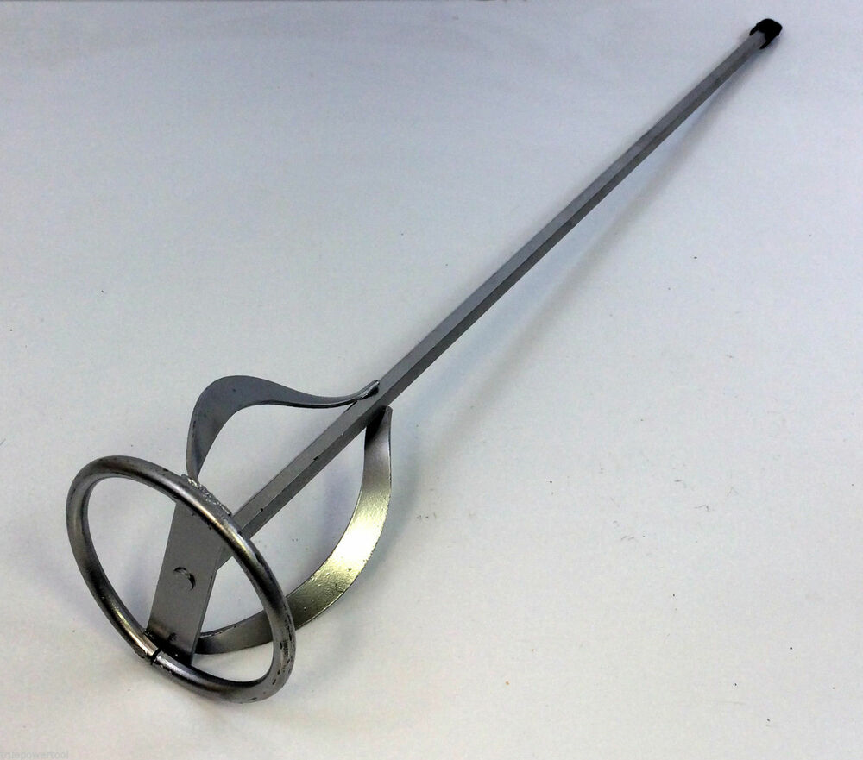

Typical paint mixing paddle

Mixing should be done for at least five minutes on a low speed to avoid forming bubbles and causing splatter, moving the paddle in an up and down motion starting at the bottom of the pail.

Once mixing is complete the paddle should be cleaned with mineral spirits in the case of solvent based adhesives such as 2170R and water in the case of water-based adhesive (WBA) such as Sarnacol 2121 and allowed to dry prior to re-use.

The same paddle must not be used for both solvent and WBA’s due to potential cross contamination.

**NOTE: Rolling or shaking the adhesive container or using a broom handle to stir the adhesive is not acceptable.**

For further information or guidance, please contact Sika Sarnafil Canada Technical Department